You have n coins and you want to build a staircase with these coins. The staircase consists of k rows where the ith row has exactly i coins. The last row of the staircase **may be** incomplete.

Given the integer n, return *the number of****complete rows****of the staircase you will build*.

**Example 1:**

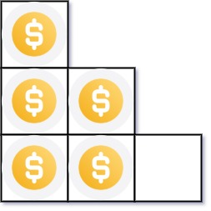

**Input:** n = 5

**Output:** 2

**Explanation:** Because the 3rd row is incomplete, we return 2.

**Example 2:**

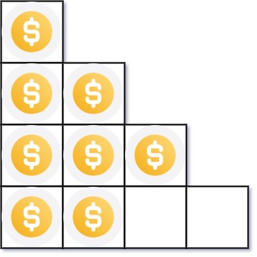

**Input:** n = 8

**Output:** 3

**Explanation:** Because the 4th row is incomplete, we return 3.

**Constraints:**

* 1 <= n <= 231 - 1